|  |  |  |  |  |  |  |  |  |  |  |  |  |  |
| --- | --- | --- | --- | --- | --- | --- | --- | --- | --- | --- | --- | --- | --- |
| 4766005*4766005* 1/43 AISA1 | | | IM | 4765950*4765950* 2/43 OMS | | AT  D6  **1/1** | 4764879*4764879* 3/43 AISA1 | | | | | | IM  D6  **1/1** |
| D19 |
| **1/1** |
| **06L03B~E** | ASR-LIS250-1G1 | | IM | **BR07A2~A** | 9-R-0083 | | **BR10A1~A** | AST-N350ZOE-A | | | | | |
| 4765543*4765543* 4/43 | | AISA1 | 4765546*4765546* 5/43 AISA1 | | IM  D11  **1/1** | 4765278*4765278* 6/43 | | | OMS | | BB | |
| D19 | D19 | |
| **1/1** | **1/1** | |
| **EL10B2~A** | WD-HC124 | | AT | **FR01A2~A** | BLF-BE90092PA-PP | | **HL01B2~O** | 9-T-0298 | | | | | |
| 4764730*4764730* 7/43 OMS | | | 4765014*4765014* 8/43 OMS | | IM  D4  **1/1** | 4764760*4764760* 9/43 OMS | | | | | BB  D26  **1/1** | |
| D4 |
| **1/1** |
| **HL02A1~O** | 9-T-1502 | | IM | **HL02A1~O** | 9-T-1502 | | **HL02B1~O** | 9-T-1720 | | | | | |
| 4765674*4765674* 10/43 OMS | | | 4764855*4764855* 11/43 OMS | | IM  D5  **1/1** | 4764727*4764727* 12/43 OMS | | | | | AT  D20  **1/1** | |
| D26 |
| **1/1** |
| **HL02B1~O** | 9-T-1720 | | AT | **HL02B2~O** | 9-T-0039 | | **HL03B1~O** | 9-T-0104 | | | | | |
| 4765228*4765228* 13/43 OMS | | | 4765279*4765279* 14/43 OMS | | BB  D10  **1/1** | 4765292*4765292* 15/43 OMS | | | | | BB  D10  **1/1** | |
| D4 |
| **1/1** |
| **HL03B2~O** | 9-T-0011 | | AT | **HL04B1~O** | 9-T-0054 | | **HL04B1~O** | 9-T-0054 | | | | | |
| 4765246*4765246* 16/43 | | OMS | 4764978*4764978* 17/43 OMS | | IM  D19  **1/1** | 4764827*4764827* 18/43 OMS | | | | | FM  D6  **1/1** | |
| D18 |
| **1/1** |
| **HL04B2~O** | 9-T-0158 | | AT | **HL04B2~O** | 9-T-0299 | | **HL05A2~O** | 9-R-0601 | | | | | |
| 4765234*4765234* 19/43 | | OMS | 4765241*4765241* 20/43 OMS | | AT  D3  **1/1** | 4765282*4765282* 21/43 OMS | | | | | BB  D10  **1/1** | |
| D5 |
| **1/1** |
| **HL05A2~O** | 9-T-0317 | | IM | **HL06A1~O** | 9-T-1021 | | **HL06B2~O** | 9-T-0306 | | | | | |
| 4765968*4765968* 22/43 OMS | | | 4765379*4765379* 23/43 OMS | | FM  D6-1  **1/1** | 4765893*4765893* 24/43 | | | | AIS | A-AMA | |
| D6 | DEYE | |
| **1/1** | **1/1** | |
| **HL07B2~O** | 9-R-0214 | | IM | **HL08B2~O** | 9-R-1234 | | **HR04A2** | 9-EY-0106 | | | | | |
| 4766049*4766049* 25/43 | | AIS | 4765238*4765238* 26/43 AIS | | AT  D28  **1/1** | 4765519*4765519* 27/43 OMS | | | | | IM  D26  **1/1** | |
| D5 |
| **1/1** |
| **HR04B1** | 9-R-0496 | | IM | **HR05B2** | 9-T-1347 | | **HR06A1~O** | | 9-T-0605 | | | | |
| 4765031*4765031* 28/43 OMS | | | 4766007*4766007* .1 29/43 AIS | | IM  11.5  **1/3** | 4766007*4766007* .2 30/43 AIS | | | | | IM  11.5  **2/3** | |
| D27 |
| **1/1** |
| **HR07B1~O** | 9-SS-0027 | | **HR09C1** | ASTSB-SI15STI-A | | **HR09C1** | ASTSB-SI15STI-A | | | | | |

|  |  |  |  |  |  |  |  |  |  |  |  |  |
| --- | --- | --- | --- | --- | --- | --- | --- | --- | --- | --- | --- | --- |
| 4766007*4766007* 31/43 | | AIS | IM | | 4765482*4765482* 32/43 | | DDS | IM | 4765990*4765990* 33/43   DDS | | | IM |
| 11.5 | | D6 | D4 |
| **3/3** | | **1/1** | **1/1** |
| **HR09C1** | ASTSB-SI15STI-A | | | | **Z** | 9-R-0292 | | IM | **Z** | 9-R-0484-B593M | | IM |
| 4765671*4765671* 34/43 DDS | | | IM  D9  **1/1** | | 4765633*4765633* 35/43 DDS | | | 4765610*4765610* 36/43 | | DDS |
| D5 | D5 |
| **1/1** | **1/1** |
| **Z** | 9-T-0268 | | | | **Z** | 9-T-0415 | | IM | **Z** | 9-T-0486 | | IM |
| 4765740*4765740* 37/43 DDS | | | IM  D23  **1/1** | | 4764963*4764963* 38/43 OMS | | | 4765987*4765987* 39/43 | | OMS |
| D6 | D5 |
| **1/1** | **1/1** |
| **Z** | 9-T-0962 | | | | Need Location 9-T-1334 | | | IM | Need Location | 9-T-3066 | | IM |
| 4764850*4764850* .1 40/43 OMS | | | IM  D5  **1/2** | | 4764850*4764850* 41/43 OMS | | | 4766009*4766009* 42/43 OMS | | |
| D5 | D18 |
| **2/2** | **1/2** |
| **BR04B2~A** | 9­T­0185 | | | | **HL05A2~O** | 9-R-0072 | | **HL02B2~O** | 9-T-0308 | |
| 4766009*4766009* 43/43 OMS | | | | IM  D18  **2/2** |
| **HL07A2~O** | 9-R-0087 | | | |

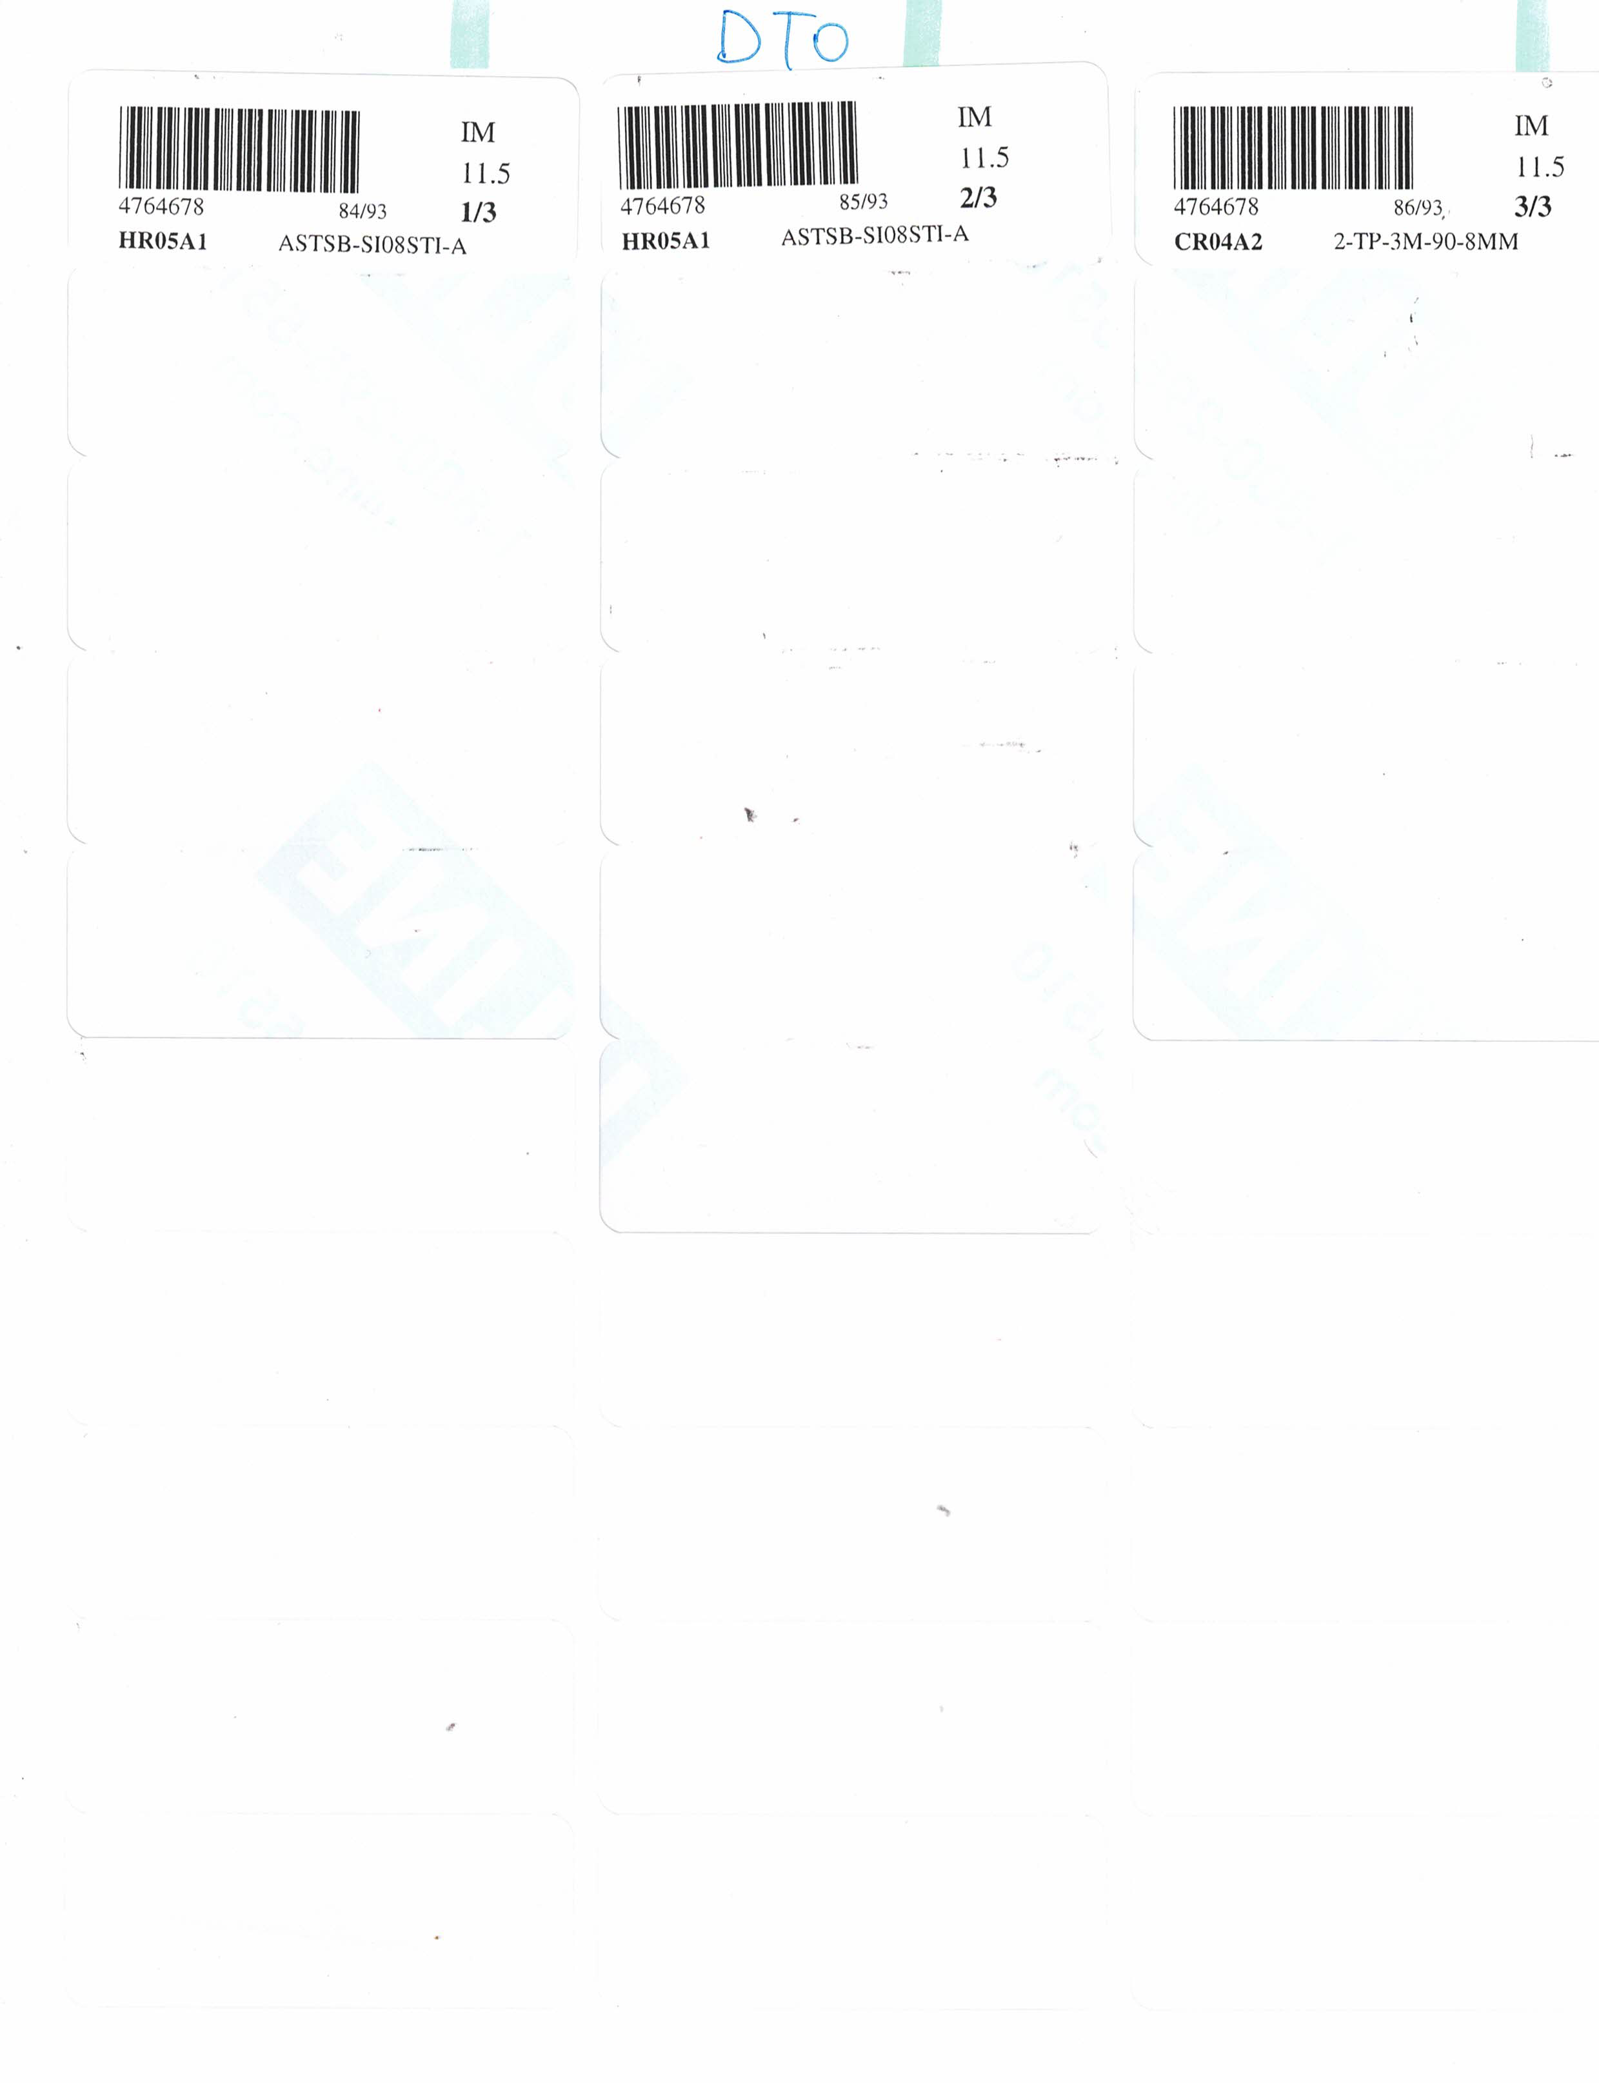

|  |  |  |
| --- | --- | --- |
| OCR | OCR | OCR |

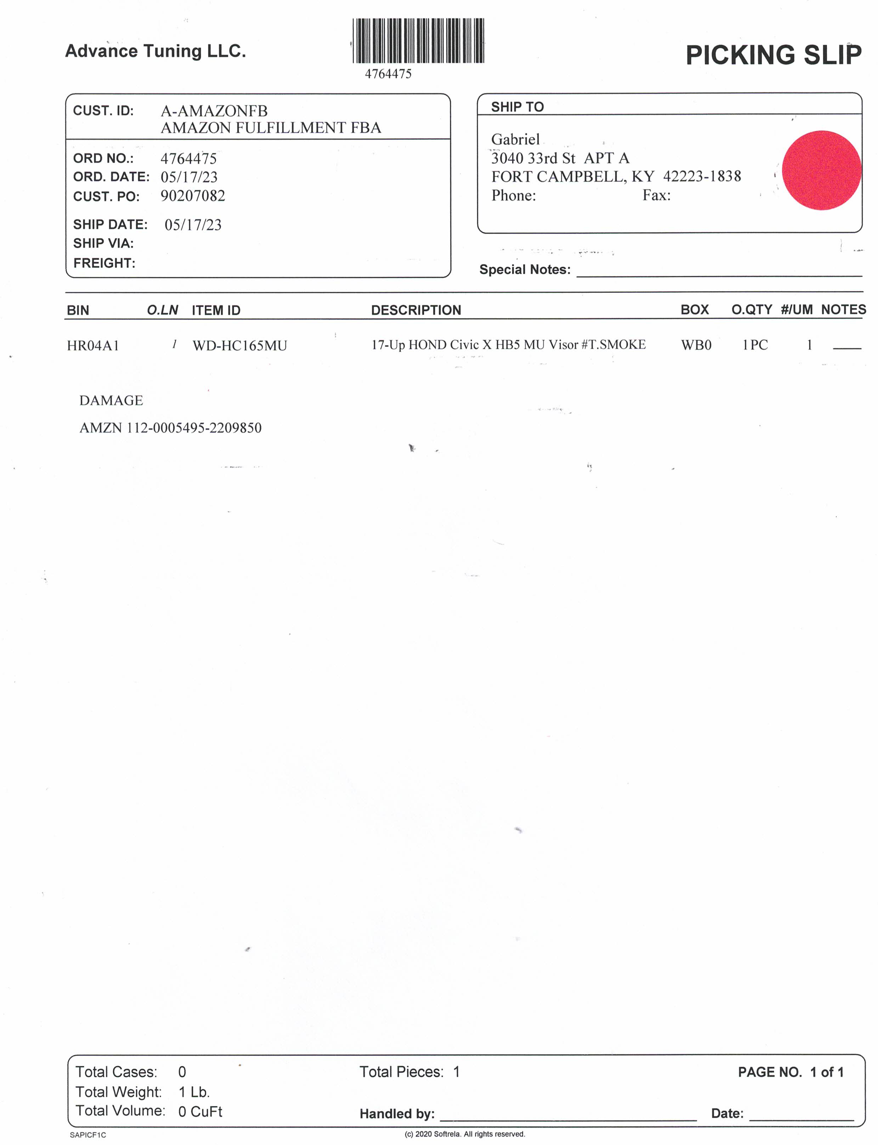

AIS

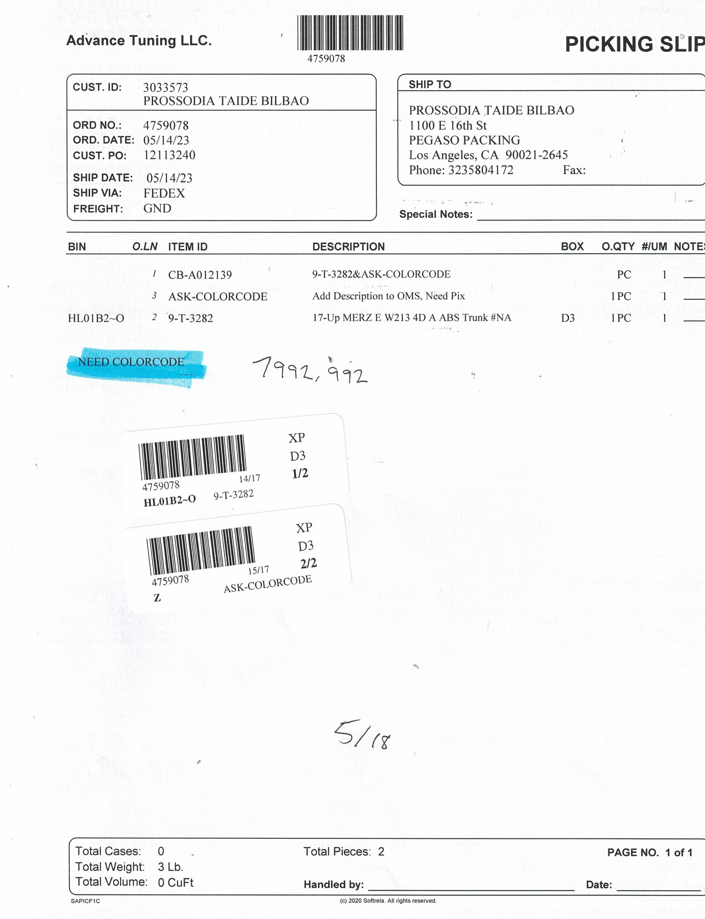

=========   
W213 TA#992   
DDS

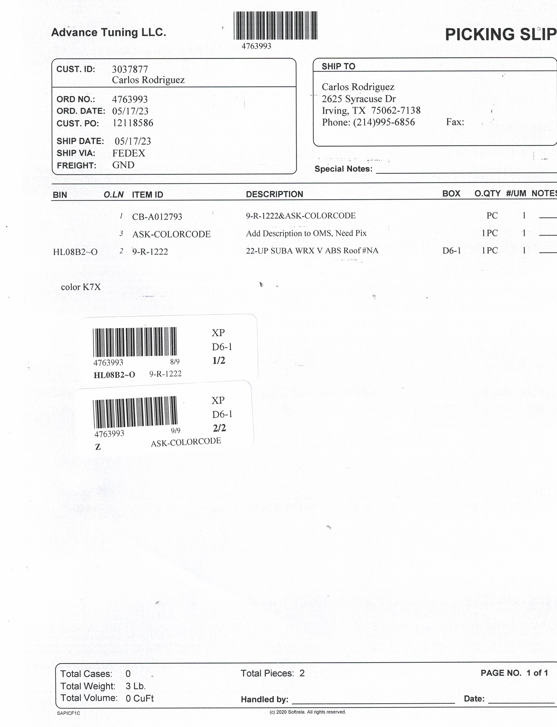

=========   
WRX5RV#K7V

DDS

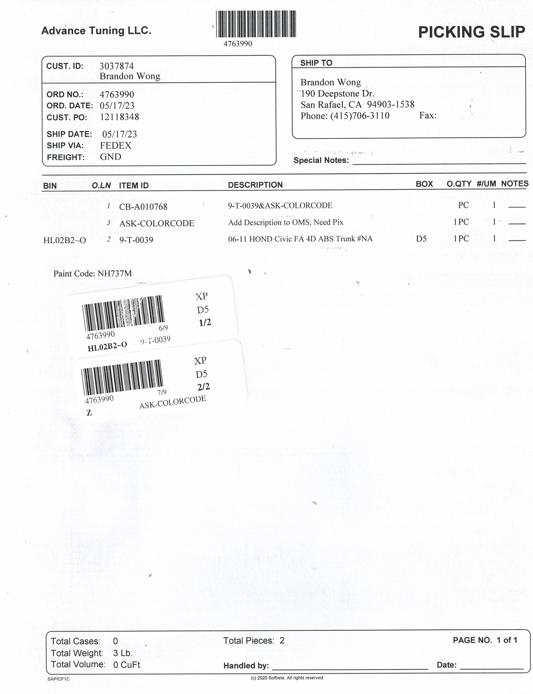

==========   
9-T-1272

AIS